


AB Bank Zambia

Monthly Report
February 2026

Contents
1. Executive Summary 2
1.1. Key Highlights: 2
1.1.1. Incident Volume & Trends: 2
1.1.2. Detection & Response Performance: 2
1.2. Incident Trends & Analysis: 3
1.3. High-Severity Incidents: 4
2. February Alerts & Incidents Overview 4
2.1. Overall Volume 4
2.2. Incidents Processing 5
2.3. Mean Time To Detect (MTTD) 5
3. Incidents Highlights 6
3.1. Top Incidents by type 6
3.2. Analysis of Key Incident Trends 7
3.3. High Severity 9
1. Non Domain Controller Active Directory Replication (15 Incidents) 9
2. Preview: Possible multistage attack activities detected by Fusion (2 Incidents) 9
4. Cybersecurity Trends and Threats - Zambia (February 1–28, 2026) 10
4.1. Key Threats and Incidents 10
4.2. Regional Spillover and Infrastructure Risks 11
4.3. Government and Infrastructure Response 12
5. Conclusion and Recommendations 13
5.1. Recommendations 13
5.2. Conclusion 14
Appendix – Test-server Alerts 15
Total Incidents by Severity 15
Top 10 Incidents 15
High Severity Incidents 15

Executive Summary
This security report provides an in-depth analysis of security incidents, alerts, and operational activities managed by TeKnowledge for AB Bank Zambia during the reporting period (February 2026). The findings highlight key security trends, detection and response performance, and proactive measures taken to enhance the organization’s security posture.

Key Highlights:

Incident Volume & Trends:
A total of 864 security incidents were generated in the Production environment and 0 Security incidents in the Test Environment. All incidents were processed in Microsoft Sentinel, encompassing both manually investigated cases and automated detections.
The most prevalent security events still include Authentication Attempt - Default Account, FortiGate Successful Login, User Account Modified, Source Stopped Sending Data: Syslog and FortiGate Configuration Change highlighting the performance of the Security Environment on Administrative account login and User-Account Management in the Security environment, Notification of Change and Log Monitor Status.

Detection & Response Performance:
Mean Time to Detect (MTTD): 2 minutes and 17 seconds, ensuring timely identification of incidents.
Additionally, the breakdown of MTTD by severity is as follows:
High Severity: 2 minute and 7 seconds
Medium Severity: 2 minutes and 17 seconds
Low Severity: 1 minutes and 12 seconds
Informational: 2 minutes and 42 seconds

Average time to First Response: The average Time to First Response was 6 minutes. See the screenshot below for the breakdown according to the incidents’ severity.
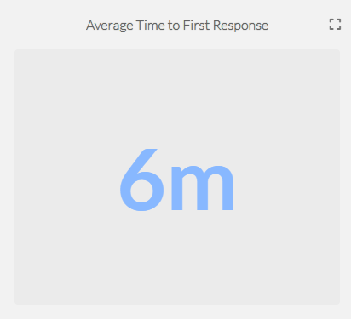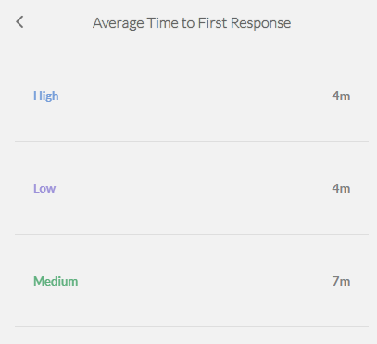
Mean Time to Resolution (MTTR): The average Mean Time to Resolution (MTTR) for this reporting period was 16 minutes. The screenshot below provides a detailed breakdown by severity.
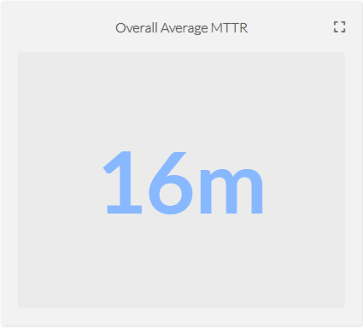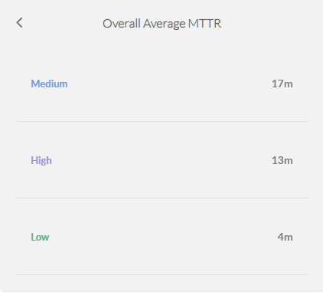

Incident Trends & Analysis:
The top recurring incident types identified in February accounted for 642 of the total incidents. These incidents were mainly tied to Authentication Attempt - Default Account, FortiGate Successful Login, User Account Modified, Source Stopped Sending Data: Syslog and FortiGate Configuration Change indicating Administrative Account Authentication Notifications, Access-Notification to VPN and Log-Server Operational Status.
The most frequent alerts were related to:
- Authentication Attempt - Default Account – 253
- FortiGate Successful Login – 188
- User Account Modified – 111
- Source Stopped Sending Data: Syslog – 51
- FortiGate Configuration Change - 39
All these incidents were thoroughly reviewed and escalated where necessary, helping to maintain Operational stability and security to the critical Assets.

High-Severity Incidents:
A total of 25 alerts were categorized as high severity, which entails Non Domain Controller Active Directory Replication. The high-severity case confirmed to be carried out by The Dedicated Service-Account for Active Directory Replication.

February Alerts & Incidents Overview

Overall Volume
In the month of February, a total of 864 incidents from production environment were handled on MS Sentinel. Further breakdown in severity showed that 25 were of High Severity, 800 were of Medium Severity, 11 were of Low Severity and 28 Informational Incidents. This volume includes manually-processed incidents and automatically-addressed incidents: through pre-configured automation protocols.

Incidents Processing
During the reporting period, TeKnowledge successfully monitored, detected, and responded to a total of 864 security incidents within the AB Bank Zambia production environment. The SOC team processed all incidents, ensuring a comprehensive approach to threat detection and response.

Mean Time To Detect (MTTD)
The average Mean Time to Detect (MTTD) for this reporting period was 2 minutes and 17 seconds. Average detection time for High-severity was 2 minute 7 seconds, Medium-severity was 2 minutes 17 seconds, Low-severity was 1 minutes 12 seconds, and Informational incidents were averagely detected at 2 minutes 42 seconds

Incidents Highlights

Top Incidents by type
During the reporting period, TeKnowledge monitored security incidents, identifying the most prevalent issues within your environment. Below is a breakdown of the top incident types detected:

Incident Title | Count of Title
Authentication Attempt - Default Account | 253
FortiGate Successful Login | 188
User Account Modified | 111
Source Stopped Sending Data: Syslog | 51
FortiGate Configuration Change | 39
Monitor for keylogging activity | 31
Incident Summary Alert | 28
Non Domain Controller Active Directory Replication | 28
FortiGate Logon Failure | 26
User Account Created/Enabled | 19
Grand Total | 774

Analysis of Key Incident Trends
During this reporting period, TeKnowledge identified and categorized multiple security incidents within the AB Bank Zambia production environment. The breakdown below highlights key trends, notable threat patterns, and actionable recommendations to improve detection and response capabilities
- Authentication Attempt-Default Account (253 Incidents)
Description: This rule monitors authentication attempts using default accounts like "Administrator," "Root," or "Guest." It searches for specific logon event types (4624, 4625, 4768, 4771, 4648, 4801) and checks if the account being used is one of the default names.
Observations: These incidents were confirmed to be generated by legitimate service accounts dedicated to specific service in the environment.

- FortiGate Successful Login (188 Incidents)
Description: This rule detects successful logins to FortiGate's management console by parsing the Syslog messages and extracting login details like user, source IP, and destination IP.
Observation: All the VPN connections were confirmed to be from legitimate and authorized users.
- User Account Modified (111 Incidents)
Description: This rule detects modifications made to user accounts in Active Directory by monitoring Event ID 4738. It focuses on changes to user account attributes and identifies the account and subject responsible for the modification
Observation: These User account modifications were confirmed to be carried out by authorized IT Systems Administrators.

- Source Stopped Sending Data: Syslog (51 Incidents)
Description: This rule monitors the Syslog table for data flow and triggers an alert if the number of Syslog records drops below 1,000, indicating a potential data loss from the source.
Review: These incidents were escalated to the Network Team
- FortiGate Configuration Change (39 Incidents)
Description: This rule detects configuration changes on FortiGate firewalls by monitoring Syslog messages that indicate a change and extracting details such as the user and device involved.
Feedback: The incident was confirmed to be carried out by authorized IT and Network Administrators. The configuration change was legitimate.
- Monitor for keylogging activity (31 Incidents)
Description: This rule detects keylogging activity from Servers within the Environment.
Feedback: These were triggered from legitimate users who logged in a PRTG application and no malicious activity was found
- Incident Summary Alert (28 Incidents)
Description: This rule produces a summary count of incidents generated in the past 12hrs.
- Non Domain Controller Active Directory Replication (28 Incidents)
Description: This query detects potential attempts by non-computer accounts (non domain controllers) to retrieve/synchronize an active directory object leveraging directory replication services (DRS). A Domain Controller (computer account) would usually be performing these actions in a domain environment. Another detection rule can be created to cover domain controllers accounts doing at rare times. A domain user with privileged permissions to use directory replication services is rare.
Observation: The Domain controller Replication activities were confirmed to be scheduled task assigned to dedicated service-account
- FortiGate Logon Failure (26 Incidents)
Description: This rule detects failed login attempts on FortiGate devices' administrative interface. It parses the Syslog messages for failure events, while excluding specific benign scenarios.
Observation: These were triggered from legitimate users who made mistakes in the login password and/or ssh error due to expired token.

.
- User Account Created/Enabled (19 Incidents)
Description: This rule detects the creation or enabling of user accounts in Active Directory by monitoring for Event IDs 4720 and 4722. It logs details about the subject user and the target account being created or enabled.
Observation: The User Account management activity, which entails creation, enable and disable was confirmed to be carried out by Authorized IT Administrators.

High Severity
During the reporting period, 28 high-severity incidents were recorded.
Incident Title | Count of Title
Non Domain Controller Active Directory Replication | 28
Grand Total | 28

- Non Domain Controller Active Directory Replication (28 Incidents)
Review: This rule detects potential attempts by non-computer accounts (non domain controllers) to retrieve/synchronize an active directory object leveraging directory replication services (DRS). A Domain Controller (computer account) would usually be performing these actions in a domain environment.
On further investigation, it was discovered that this was an authorized activity of a dedicated Service-Account for Azure AD Connect synchronization.

Cybersecurity Trends and Threats - Zambia (February 1–28, 2026)
In February 2026, Zambia's threat landscape (as seen in open reporting and official/public-interest statements published was dominated by social engineering-driven fraud (especially SMS/payment scams targeting vulnerable citizens) and a sharp rise in information manipulation using Al-assisted synthetic media (deepfakes) and coordinated online abuse. Public communications during the month also show a clear defensive posture: enforcement messaging tied to the Cyber Security Act of 2025, plus multi-stakeholder initiatives aimed at protecting the information environment ahead of the 2026 general elections.

Key Threats and Incidents
Payment/SMS scams targeting Social Cash Transfer (SCT) beneficiaries (fraud + identity/data theft)
February 4, 2026 reporting captured a spike in fake SCT payment messages designed to trick recipients into sharing personal details or losing money. Official messaging (as carried by ZANIS) warned beneficiaries not to trust unknown senders, not to share PINs, and to report suspicious messages to authorities. This is a classic, high-impact pattern: impersonation + urgency + financially vulnerable targets.
Why it matters (threat emphasis):
• High reach, low cost for criminals (mass SMS/WhatsApp blasts).
• Targets populations least able to absorb losses.
• Often linked to broader mobile-money fraud ecosystems (SIM swaps, mule accounts, fake "agents").
• Al-enabled disinformation and synthetic media targeting public figures (deepfakes)
On February 17, 2026, ZICTA publicly raised alarm about increasing misuse of Al to create fake images/videos and spread false information online, framing it as a national security concern as the country approaches elections and indicating the Cyber Security Act of 2025 would be enforced.
This threat moved from "warning" to "real-world enforcement signal" later in the month: Africanews (Feb 25, 2026) reported the arrest of a politician over a digitally altered image posted to Facebook depicting the president in a casket.
Why it matters (threat emphasis):
• Deepfakes and manipulated media can drive panic, reputational damage, and public disorder fast.
• They are increasingly used alongside harassment/hate campaigns and coordinated inauthentic behavior (especially around elections).
• Online child sexual exploitation risk amplified by generative Al (Al "nudification" and synthetic CSAM)
In early February 2026, UNICEF issued warnings about the fast-growing harm from Al-generated sexualized images, including "nudification" (using Al tools to fabricate nude/sexualized images) and broader exploitation risks. While this is a global warning, it is directly relevant to Zambia's February posture because Zambia's public messaging in the same month strongly focused on online safety, youth protection, and synthetic media harms.
Why it matters (threat emphasis):
• Victims can be harmed even when content is fabricated (lasting psychological, reputational, and safety impacts).
• The speed of distribution on social platforms outpaces reporting/removal.
• Creates heavy investigative burden (attribution, victim identification, cross-border hosting).
• Cross-border online scam activity as an enabling backdrop (regional pressure on Zambia)
On February 18, 2026, INTERPOL reported results of a multi-country operation against online scams (investment fraud, mobile money fraud, fraudulent loan apps), reinforcing how transnational scam infrastructure remains highly active across Africa conditions that typically increase spillover attempts against neighboring and economically connected markets like Zambia.

Regional Spillover and Infrastructure Risks
Transnational scam models and infrastructure
INTERPOL's February 2026 reporting highlights scam ecosystems that rely on cross-border coordination, shared platforms, and quickly replaceable infrastructure (devices, SIMs, malicious domains/IPs). Zambia's February SCT scam spike fits this broader continental reality: even when victims are local, the tooling and playbooks are often regionalized.
Election-cycle information risk: misinformation, disinformation, hate speech
UNDP's February 17, 2026 announcement of iVerify Zambia 2.0 explicitly frames the 2026 elections as a period of vulnerability, citing Al-driven manipulation, deepfakes, and coordinated behavior. Zambia's February arrest over doctored imagery is consistent with this risk profile.
Human-targeted compromise remains the dominant access vector
Across the February incidents and warnings, the common thread is people-focused attack paths. Fake payment notifications and impersonation scams (SCT).
• Al-assisted manipulation to deceive or provoke.
• Harassment/abuse with synthetic content.
This matters because defenses that focus only on perimeter controls will miss the highest-volume risk: social engineering at scale.
Youth online exposure expands the attack surface
Safer Internet Day 2026 messaging from SMART Zambia (dated February 17, 2026) emphasized that as digital access expands via e-government and broader connectivity, risks such as cybercrime, exploitation, and misinformation become more acute especially for young users.

Government and Infrastructure Response
Public enforcement posture under the Cyber Security Act of 2025: ZICTA's February 17, 2026 statements emphasized that the Cyber Security Act would be strictly enforced, with references to arrests/appearances before court for online abuse and misinformation activity. Fraud disruption via public warnings and reporting channels Government messaging in early February pushed citizens to:
•Trust only official SCT communications,
• Avoid sharing PINS,
• Report suspicious messages and numbers (including referral to ZICTA and police).

Building election-period information integrity capability (iVerify Zambia 2.0):
UNDP's February 17, 2026 release describes iVerify Zambia 2.0 as a mechanism combining monitoring/early warning with verification workflows and media literacy interventions directly aimed at misinformation/disinformation and hate speech threats as elections approach.

Elevating child online protection in the Al era:
UNICEF's February 2026 statements (carried by UN Geneva/UNRIC) call for criminalization/definition updates around Al- generated CSAM and stronger platform guardrails-relevant to Zambia's online safety posture and the wider regional push to modernize legal and operational safeguards against Al-enabled abuse.

Sources: Lusaka Times , UNDP, Africa News, Zanis, UN Geneva, MCDSS, Zambian Eye, Open Zambia, UNRIC, Interpol, SZI

Conclusion and Recommendations

Recommendations
Optimize Analytic Rules: Standardize entity mapping (Account, Host, IP, Process, File Hash, URL/Domain) across analytic rules to improve auto-grouping, speed up triage, reduce noise from non-production systems, and enhance reporting accuracy.
Expand SSH Detection: Develop additional analytic rules to increase visibility into SSH-based connections and activities, ensuring comprehensive coverage of remote-access behaviour.
Ensure Agent Resilience: Configure all log-forwarding agents to start automatically after reboots and set service recovery options to restart on failure, preventing data gaps after maintenance or outages.
Detect Log Gaps: Setup an analytic rule that flags servers with missing or delayed log data, enabling quick identification and remediation of sources that stop sending events.
Correct “Heartbeat Missing” Rule Configuration: Update the Rule Period from 30 minutes to 6–12 hours to broaden detection coverage and configure Event Grouping to “Group all events into a single alert”.
Emphasis on WithSecure EDR Integration with Microsoft Sentinel: Integrating WithSecure EDR with Microsoft Sentinel is recommended to improve security visibility and efficiency. This integration centralizes endpoint and cloud workload security events into a single monitoring platform, enhancing situational awareness and event correlation. By unifying security data within Sentinel, organizations can streamline investigations, automate responses, and accelerate incident detection and remediation, ultimately strengthening overall threat response capabilities.

Conclusion
The February 2026 reporting period marked a significant step forward in the security operations of AB Bank Zambia, with TeKnowledge continuing to provide dedicated 24/7 monitoring, incident detection, and rapid response through the Microsoft Sentinel platform. A total of 864 alerts were processed a significant increase from the previous month reflecting the need for optimization of the analytical rules in the environment.
The most detected threats included Authentication Attempt - Default Account, FortiGate Successful Login, User Account Modified, Source Stopped Sending Data: Syslog and FortiGate Configuration Change underscoring the need for sustained vigilance in identity/access management as well as operational status of critical assets.
TeKnowledge’s SOC demonstrated high operational efficiency, with the following key performance:
- Mean Time to Detect (MTTD): 2 minutes and 17 seconds
- Average Time to First Response: 6 minutes
- Average Mean Time to Resolution: 16 minutes

28 high-severity incidents were recorded during this period.
As we move forward, TeKnowledge remains dedicated to strengthening your organization’s defences through:
- Continuous monitoring, rapid threat detection and Incident escalation
- Strategic improvements to rule coverage and incident handling workflows

We appreciate the trust placed in TeKnowledge to safeguard AB Bank Zambia’s digital environment and look forward to our continued partnership in building a more secure and resilient infrastructure.

Appendix – Test-server Alerts
This section documents alerts generated on test servers (non-critical) during the reporting period. These events are excluded from SLA/MTTR metrics and captured for transparency and auditability.

Total Incidents by Severity
Severity | Count of Severity
Medium | 0
Grand Total | 0

Top 10 Incidents
Title | Sum by Title
User Added to Critical Group | 0
Grand Total | 0

High Severity Incidents
Title | Count of Title
Nil | 0
Grand Total | 0

